**EXPERIMENT NO. 05**

|  |  |
| --- | --- |
| **DATE OF PERFORMANCE:** | **GRADE:** |
| **DATE OF ASSESSMENT:** | **SIGNATURE OF LECTURER/ TTA:** |

**AIM: Introduction to Java Script.**

**THEORY:**

**JAVASCRIPT:**

**An object-oriented computer programming language commonly used to create interactive effects within web browsers.**

**JavaScript is the programming language of HTML and the Web. Programming makes computers do what you want them to do.**

**JavaScript is a scripting language, that is, a lightweight programming language that is interpreted by the browser engine when the web page is loaded.**

**WHY STUDY JAVASCRIPT?**

**JavaScript is one of the 3 languages all web developers must learn:**

**1. HTML to define the content of web pages**

**2. CSS to specify the layout of web pages**

**3. JavaScript to program the behavior of web pages.**

**JAVASCRIPT CAN CHANGE HTML CONTENT:**

**One of many JavaScript HTML methods is getElementById().**

**This example uses the method to "find" an HTML element (with id="demo") and changes the element content (innerHTML) to "Hello JavaScript":**

***Example: document.getElementById("demo").innerHTML = "Hello JavaScript";***

**JAVASCRIPT WHERE TO:**

**JavaScript can be placed in the <body> and the <head> sections of an HTML page.**

**The <script> Tag**

**In HTML, JavaScript code must be inserted between <script> and </script> tags.**

***Example:***

***<script>  
document.getElementById("demo").innerHTML = "My First JavaScript";  
</script>***

**JAVASCRIPT FUNCTIONS AND EVENTS:**

**A JavaScript function is a block of JavaScript code, that can be executed when "asked" for. For example, a function can be executed when an event occurs, like when the user clicks a button.**

**JavaScript in <head> or <body>**

**You can place any number of scripts in an HTML document. Scripts can be placed in the <body>, or in the <head> section of an HTML page, or in both.**

**JAVASCRIPT IN <HEAD>:**

**A JavaScript function is placed in the <head> section of an HTML page.**

**The function is invoked (called) when a button is clicked:**

***Example***

***<!DOCTYPE html>  
<html>***

***<head>  
<script>  
function myFunction() {  
    document.getElementById("demo").innerHTML = "Paragraph changed.";  
}  
</script>  
</head>***

***<body>***

***<h1>My Web Page</h1>***

***<p id="demo">A Paragraph</p>***

***<button type="button" onclick="myFunction()">Try it</button>***

***</body>  
</html>***

**JAVASCRIPT IN <BODY>:**

**JavaScript function is placed in the <body> section of an HTML page. The function is invoked (called) when a button is clicked:**

***Example***

***<!DOCTYPE html>  
<html>  
<body>   
  
<h1>My Web Page</h1>  
  
<p id="demo">A Paragraph</p>  
  
<button type="button" onclick="myFunction()">Try it</button>  
  
<script>  
function myFunction() {  
   document.getElementById("demo").innerHTML = "Paragraph changed.";  
}  
</script>  
  
</body>  
</html>***

**EXTERNAL JAVASCRIPT:**

**Scripts can also be placed in external files:**

***myScript.js***

***function myFunction() {  
   document.getElementById("demo").innerHTML = "Paragraph changed.";  
}***

**External scripts are practical when the same code is used in many different web pages.**

**JavaScript files have the file extension .js.**

**To use an external script, put the name of the script file in the src (source) attribute of a <script> tag:**

***Example:***

***<!DOCTYPE html>  
<html>  
<body>  
<script src="myScript.js"></script>  
</body>  
</html>***

**EXTERNAL JAVASCRIPT ADVANTAGES:**

**Placing JavaScripts in external files has some advantages:**

* **It separates HTML and code**
* **It makes HTML and JavaScript easier to read and maintain**
* **Cached JavaScript files can speed up page loads.**

**JAVASCRIPT OUTPUT:**

**JavaScript does NOT have any built-in print or display functions.**

**JavaScript Display Possibilities**

**JavaScript can "display" data in different ways:**

* **Writing into an alert box, using window.alert().**
* **Writing into the HTML output using document.write().**
* **Writing into an HTML element, using innerHTML.**
* **Writing into the browser console, using console.log().**

**USING WINDOW.ALERT():**

**You can use an alert box to display data:**

***Example***

***<!DOCTYPE html>  
<html>  
<body>  
  
<h1>My First Web Page</h1>  
<p>My first paragraph.</p>  
  
<script>  
window.alert(5 + 6);  
</script>  
  
</body>  
</html>***

**USING DOCUMENT.WRITE():**

**For testing purposes, it is convenient to use document.write():**

***Example***

***<!DOCTYPE html>  
<html>  
<body>  
  
<h1>My First Web Page</h1>  
<p>My first paragraph.</p>  
  
<script>  
document.write(5 + 6);  
</script>  
  
</body>  
</html>***

**USING INNERHTML:**

**To access an HTML element, JavaScript can use the document.getElementById(id) method.**

**The id attribute defines the HTML element. The innerHTML property defines the HTML content:**

***Example***

***<!DOCTYPE html>  
<html>  
<body>  
  
<h1>My First Web Page</h1>  
<p>My First Paragraph</p>  
  
<p id="demo"></p>  
  
<script>  
document.getElementById("demo").innerHTML = 5 + 6;  
</script>  
  
</body>  
</html>***

**USING CONSOLE.LOG():**

**In your browser, you can use the console.log() method to display data.**

**Activate the browser console with F12, and select "Console" in the menu.**

***Example***

***<!DOCTYPE html>  
<html>  
<body>  
  
<h1>My First Web Page</h1>  
<p>My first paragraph.</p>  
  
<script>  
console.log(5 + 6);  
</script>  
  
</body>  
</html>***

**JAVASCRIPT PROGRAMS:**

**A computer program is a list of "instructions" to be "executed" by the computer.**

**In a programming language, these program instructions are called statements.**

**JavaScript is a programming language.**

**JavaScript statements are separated by semicolons.**

***Example***

***var x = 5;  
var y = 6;  
var z = x + y;***

**JAVASCRIPT STATEMENTS:**

**JavaScript statements are composed of:**

**Values, Operators, Expressions, Keywords, and Comments.**

**JAVASCRIPT VALUES:**

**The JavaScript syntax defines two types of values: Fixed values and variable values.**

**Fixed values are called literals. Variable values are called variables.**

**JAVASCRIPT LITERALS:**

**The most important rules for writing fixed values are:**

**Numbers are written with or without decimals:**

**10.50  
1001**

**JAVASCRIPT OPERATORS:**

**JavaScript uses an assignment operator ( = ) to assign values to variables:**

**var x = 5;  
var y = 6;**

**JAVASCRIPT EXPRESSIONS:**

**An expression is a combination of values, variables, and operators, which computes to a value.**

**The computation is called an evaluation.**

**For example, 5 * 10 evaluates to 50:**

**5 * 10**

**JavaScript Keywords**

**JavaScript keywords are used to identify actions to be performed.**

**The var keyword tells the browser to create a new variable:**

***var x = 5 + 6;  
var y = x * 10;***

**JAVASCRIPT COMMENTS:**

**Not all JavaScript statements are "executed".**

**Code after double slashes // or between /* and */ is treated as a comment.**

**Comments are ignored, and will not be executed:**

***var x = 5;   // I will be executed  
  
// var x = 6;   I will NOT be executed***

**JAVASCRIPT IDENTIFIERS:**

**Identifiers are names.**

**In JavaScript, identifiers are used to name variables (and keywords, and functions, and labels).**

**JavaScript is Case Sensitive**

**All JavaScript identifiers are case sensitive.**

**The variables lastName and lastname, are two different variables.**

***lastName = "Doe";  
lastname = "Peterson";***

**JAVASCRIPT PROGRAMS:**

**Most JavaScript programs contain many JavaScript statements.**

**The statements are executed, one by one, in the same order as they are written.**

***Example***

***var x = 5;  
var y = 6;  
var z = x + y;  
document.getElementById("demo").innerHTML = z;***

**SEMICOLONS :**

**Semicolons separate JavaScript statements.**

***a = 5;  
b = 6;  
c = a + b;***

**JavaScript White Space**

**JavaScript ignores multiple spaces. You can add white space to your script to make it more readable.**

***var person = "Hege";  
var person="Hege";***

**JAVASCRIPT CODE BLOCKS:**

**JavaScript statements can be grouped together in code blocks, inside curly brackets {...}.**

**The purpose of code blocks is to define statements to be executed together.**

***Example***

***function myFunction() {  
    document.getElementById("demo").innerHTML = "Hello Dolly.";  
    document.getElementById("myDIV").innerHTML = "How are you?";  
}***

**JAVASCRIPT KEYWORDS:**

**JavaScript statements often start with a keyword to identify the JavaScript action to be performed.**

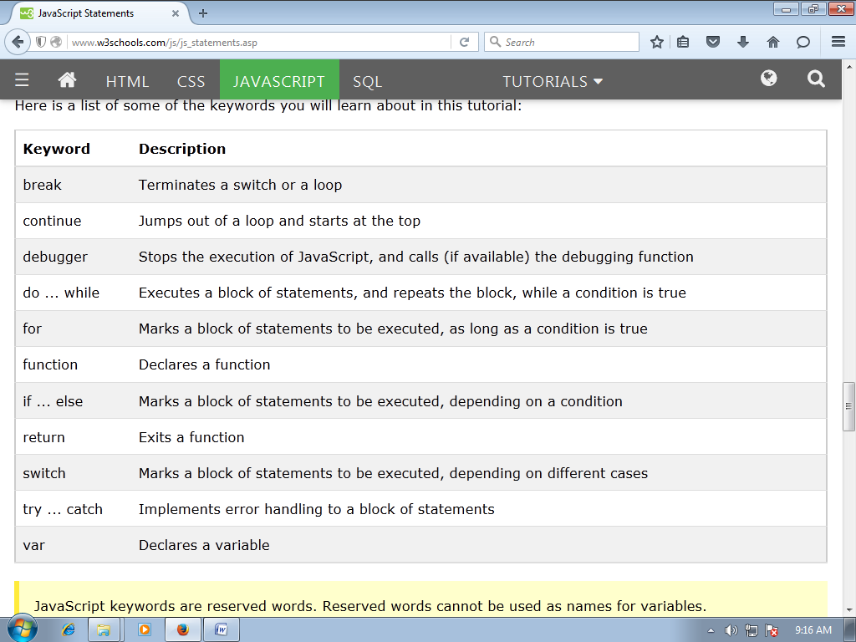

**JAVASCRIPT VARIABLES:**

**JavaScript variables are containers for storing data values.**

***Example***

***var x = 5;  
var y = 6;  
var z = x + y;***

**From the example above, you can expect:**

* **x stores the value 5**
* **y stores the value 6**
* **z stores the value 11**

**JAVASCRIPT DATA TYPES:**

**JAVASCRIPT DATA TYPES:**

**JavaScript variables can hold many data types: numbers, strings, arrays, objects and more:**

***var length = 16;                               // Number  
var lastName = "Johnson";                      // String  
var cars = ["Saab", "Volvo", "BMW"];           // Array  
var x = {firstName:"John", lastName:"Doe"};    // Object***

**THE CONCEPT OF DATA TYPES:**

**To be able to operate on variables, it is important to know something about the type.**

**Without data types, a computer cannot safely solve this:**

***var x = 16 + "Volvo";***

**JavaScript will treat the example above as:**

***var x = "16" + "Volvo";***

**When adding a number and a string, JavaScript will treat the number as a string.**

**JavaScript evaluates expressions from left to right. Different sequences can produce different results:**

***var x = 16 + 4 + "Volvo";***

***Result:***

***20Volvo***

**JAVASCRIPT HAS DYNAMIC TYPES:**

**JavaScript has dynamic types. This means that the same variable can be used as different types:**

***Example***

***var x;               // Now x is undefined  
var x = 5;           // Now x is a Number  
var x = "John";      // Now x is a String***

**JAVASCRIPT STRINGS:**

**A string (or a text string) is a series of characters like "John Doe".**

**Strings are written with quotes. You can use single or double quotes:**

***Example***

***var carName = "Volvo XC60";   // Using double quotes  
var carName = 'Volvo XC60';   // Using single quotes***

**JAVASCRIPT NUMBERS:**

**JavaScript has only one type of numbers.**

**Numbers can be written with, or without decimals:**

***Example***

***var x1 = 34.00;     // Written with decimals  
var x2 = 34;        // Written without decimals***

**JAVASCRIPT BOOLEANS:**

**Booleans can only have two values: true or false.**

***Example***

***var x = true;  
var y = false;***

**JAVASCRIPT ARRAYS:**

**JavaScript arrays are written with square brackets.**

**Array items are separated by commas.**

**The following code declares (creates) an array called cars, containing three items (car names):**

***Example:***

***var cars = ["Saab", "Volvo", "BMW"];***

**JAVASCRIPT OBJECTS:**

**JavaScript objects are written with curly braces.**

**Object properties are written as name:value pairs, separated by commas.**

***Example***

***var person = {firstName:"John", lastName:"Doe", age:50, eyeColor:"blue"};***

**THE TYPEOF OPERATOR:**

**You can use the JavaScript typeof operator to find the type of a JavaScript variable:**

***Example***

***typeof "John"                // Returns string   
typeof 3.14                  // Returns number  
typeof false                 // Returns boolean  
typeof [1,2,3,4]             // Returns object (not array, see note below)  
typeof {name:'John', age:34} // Returns object***

**UNDEFINED:**

**In JavaScript, a variable without a value, has the value undefined. The typeof is also undefined.**

**Any variable can be emptied, by setting the value to undefined. The type will also be undefined.**

***Example***

***person = undefined;          // Value is undefined, type is undefined***

**NULL:**

**In JavaScript null is "nothing". It is supposed to be something that doesn't exist.**

**Unfortunately, in JavaScript, the data type of null is an object.**

***var person = null;           // Value is null, but type is still an object***

**JAVASCRIPT OPERATORS:**

**Let us take a simple expression 4 + 5 is equal to 9. Here 4 and 5 are called operands and ‘+’ is called the operator. JavaScript supports the following types of operators.**

* **Arithmetic Operators**
* **Comparision Operators**
* **Logical (or Relational) Operators**
* **Assignment Operators**
* **Conditional (or ternary) Operators**

**ARITHMETIC OPERATORS:**

|  |  |
| --- | --- |
| **Sr.No** | **Operator and Description** |
| 1 | **+ (Addition)**  Adds two operands. **Ex:** A + B will give 30 |
| 2 | **- (Subtraction)**  Subtracts the second operand from the first. **Ex:** A - B will give -10 |
| 3 | **\* (Multiplication)**  Multiply both operands. **Ex:** A * B will give 200 |
| 4 | **/ (Division)**  Divide the numerator by the denominator. **Ex:** B / A will give 2 |
| 5 | **% (Modulus)**  Outputs the remainder of an integer division.**Ex:** B % A will give 0 |
| 6 | **++ (Increment)**  Increases an integer value by one. **Ex:** A++ will give 11 |
| 7 | **-- (Decrement)**  Decreases an integer value by one. **Ex:** A-- will give 9 |

**COMPARISON OPERATORS:**

|  |  |
| --- | --- |
| **Sr.No** | **Operator and Description** |
| **1** | **= = (Equal)**  **Checks if the value of two operands are equal or not, if yes, then the condition becomes true.**  **Ex: (A == B) is not true.** |
| **2** | **!= (Not Equal)**  **Checks if the value of two operands are equal or not, if the values are not equal, then the condition becomes true.**  **Ex: (A != B) is true.** |
| **3** | **> (Greater than)**  **Checks if the value of the left operand is greater than the value of the right operand, if yes, then the condition becomes true.**  **Ex: (A > B) is not true.** |
| **4** | **< (Less than)**  **Checks if the value of the left operand is less than the value of the right operand, if yes, then the condition becomes true.**  **Ex: (A < B) is true.** |
| **5** | **>= (Greater than or Equal to)**  **Checks if the value of the left operand is greater than or equal to the value of the right operand, if yes, then the condition becomes true.**  **Ex: (A >= B) is not true.** |
| **6** | **<= (Less than or Equal to)**  **Checks if the value of the left operand is less than or equal to the value of the right operand, if yes, then the condition becomes true.**  **Ex: (A <= B) is true.** |

**BITWISE OPERATORS:**

**JavaScript supports the following bitwise operators.**

**Assume variable A holds 2 and variable B holds 3, then**

|  |  |
| --- | --- |
| **Sr.No** | **Operator and Description** |
| **1** | **& (Bitwise AND)**  **It performs a Boolean AND operation on each bit of its integer arguments.**  **Ex: (A & B) is 2.** |
| **2** | **| (BitWise OR)**  **It performs a Boolean OR operation on each bit of its integer arguments.**  **Ex: (A | B) is 3.** |
| **3** | **^ (Bitwise XOR)**  **It performs a Boolean exclusive OR operation on each bit of its integer arguments. Exclusive OR means that either operand one is true or operand two is true, but not both.**  **Ex: (A ^ B) is 1.** |
| **4** | **~ (Bitwise Not)**  **It is a unary operator and operates by reversing all the bits in the operand.**  **Ex: (~B) is -4.** |
| **5** | **<< (Left Shift)**  **It moves all the bits in its first operand to the left by the number of places specified in the second operand. New bits are filled with zeros. Shifting a value left by one position is equivalent to multiplying it by 2, shifting two positions is equivalent to multiplying by 4, and so on.**  **Ex: (A << 1) is 4.** |
| **6** | **>> (Right Shift)**  **Binary Right Shift Operator. The left operand’s value is moved right by the number of bits specified by the right operand.**  **Ex: (A >> 1) is 1.** |
| **7** | **>>> (Right shift with Zero)**  **This operator is just like the >> operator, except that the bits shifted in on the left are always zero.Ex: (A >>> 1) is 1.** |

**MISCELLANEOUS OPERATOR:**

**CONDITIONAL OPERATOR (? :)**

**The conditional operator first evaluates an expression for a true or false value and then executes one of the two given statements depending upon the result of the evaluation.**

|  |  |
| --- | --- |
| **Sr.No** | **Operator and Description** |
| **1** | **? : (Conditional )**  **If Condition is true? Then value X : Otherwise value Y** |

**PROGRAM 1:JAVASCRIPT ARITHMETIC OPERATOR.**

**<html>**

**<body>**

**<script type="text/javascript">**

**<!--**

**var a = 33;**

**var b = 10;**

**var c = "Test";**

**var linebreak = "<br />";**

**document.write("a + b = ");**

**result = a + b;**

**document.write(result);**

**document.write(linebreak);**

**document.write("a - b = ");**

**result = a - b;**

**document.write(result);**

**document.write(linebreak);**

**document.write("a / b = ");**

**result = a / b;**

**document.write(result);**

**document.write(linebreak);**

**document.write("a % b = ");**

**result = a % b;**

**document.write(result);**

**document.write(linebreak);**

**a = ++a;**

**document.write("++a = ");**

**result = ++a;**

**document.write(result);**

**document.write(linebreak);**

**b = --b;**

**document.write("--b = ");**

**result = --b;**

**document.write(result);**

**document.write(linebreak);**

**//-->**

**</script>**

**Set the variables to different values and then try...**

**</body>**

**</html>**

**OUTPUT:**

**PROGRAM 2: USE OF COMPARISON OPERATOR.**

**<html>**

**<body>**

**<script type="text/javascript">**

**var a = 10;**

**var b = 20;**

**var linebreak = "<br />";**

**document.write("(a == b) => ");**

**result = (a == b);**

**document.write(result);**

**document.write(linebreak);**

**document.write("(a < b) => ");**

**result = (a < b);**

**document.write(result);**

**document.write(linebreak);**

**document.write("(a > b) => ");**

**result = (a > b);**

**document.write(result);**

**document.write(linebreak);**

**document.write("(a != b) => ");**

**result = (a != b);**

**document.write(result);**

**document.write(linebreak);**

**document.write("(a >= b) => ");**

**result = (a >= b);**

**document.write(result);**

**document.write(linebreak);**

**document.write("(a <= b) => ");**

**result = (a <= b);**

**document.write(result);**

**document.write(linebreak);**

**</script>**

**Set the variables to different values and different operators and then try...**

**</body>**

**</html>**

**OUTPUT:**

**PROGRAM 3: USE OF BITWISE OPERATOR.**

**<html>**

**<body>**

**<script type="text/javascript">**

**<!--**

**var a = 2; // Bit presentation 10**

**var b = 3; // Bit presentation 11**

**var linebreak = "<br />";**

**document.write("(a & b) => ");**

**result = (a & b);**

**document.write(result);**

**document.write(linebreak);**

**document.write("(a | b) => ");**

**result = (a | b);**

**document.write(result);**

**document.write(linebreak);**

**document.write("(a ^ b) => ");**

**result = (a ^ b);**

**document.write(result);**

**document.write(linebreak);**

**document.write("(~b) => ");**

**result = (~b);**

**document.write(result);**

**document.write(linebreak);**

**document.write("(a << b) => ");**

**result = (a << b);**

**document.write(result);**

**document.write(linebreak);**

**document.write("(a >> b) => ");**

**result = (a >> b);**

**document.write(result);**

**document.write(linebreak);**

**//-->**

**</script>**

**</body>**

**</html>**

**OUTPUT:**

**PROGRAM 4: USE OF TERNARY OPERATOR.**

**<html>**

**<body>**

**<script type="text/javascript">**

**<!--**

**var a = 10;**

**var b = 20;**

**var linebreak = "<br />";**

**document.write ("((a > b) ? 100 : 200) => ");**

**result = (a > b) ? 100 : 200;**

**document.write(result);**

**document.write(linebreak);**

**document.write ("((a < b) ? 100 : 200) => ");**

**result = (a < b) ? 100 : 200;**

**document.write(result);**

**document.write(linebreak);**

**//-->**

**</script>**

**<p>Set the variables to different values and different operators and then try...</p>**

**</body>**

**</html>**

**OUTPUT:**

**PROGRAM 5: USE OF DATA TYPE.**

**<!DOCTYPE html>**

**<html>**

**<body>**

**<p id="demo"></p>**

**<script>**

**var x = "Volvo" + 16 + 4;**

**document.getElementById("demo").innerHTML = x;**

**</script>**

**</body>**

**</html>**

**OUTPUT:**